Furniture Catalog
Upload the solution, WITH images!
Create a Web page (HTML5 + CSS3 + images) that looks and behaves like the screenshot below:
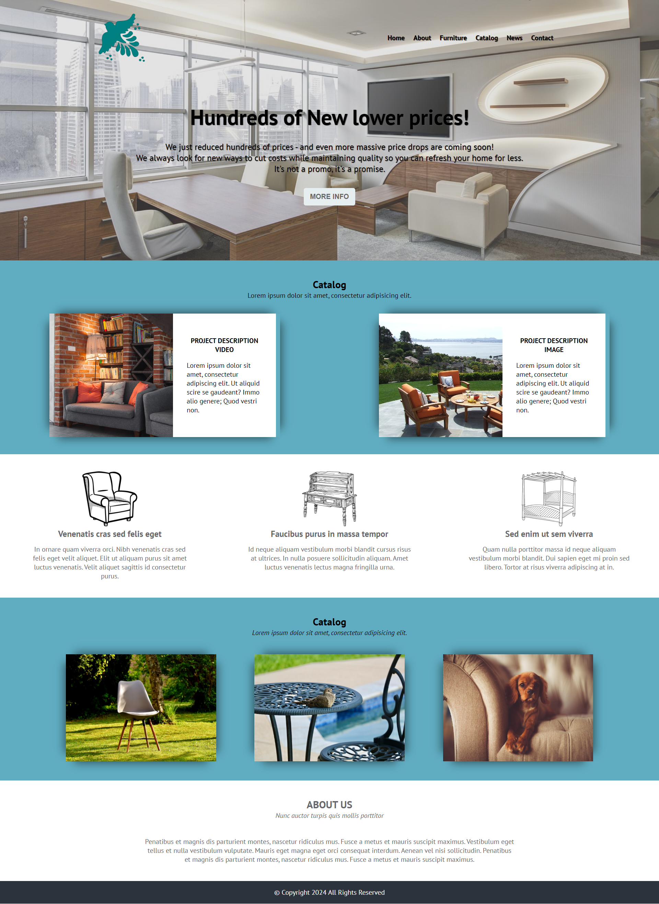
You are given the above screenshots + all required images.

Output
The output should be valid HTML5 + CSS3 + images that implement the above web page.

Constraints
- Use font PT Sans:
  - https://fonts.googleapis.com/css?family=PT+Sans:400,400i,700,700i|PT+Serif:400,400i,700,700i&amp;display=swap
- The site should open correctly in the latest version of Chrome.

